# Marcu 5.1-20

### Text UBS4: The Healing of the Gerasene Demoniac, (Mt 8.28-34; Lk 8.26-39)

1 Καὶ ἦλθον εἰς τὸ πέραν τῆς θαλάσσης εἰς τὴν χώραν τῶν Γερασηνῶν1. 2 * καὶ ἐξελθόντος αὐτοῦ ἐκ τοῦ πλοίου εὐθὺς ὑπήντησεν αὐτῷ ἐκ τῶν μνημείων ἄνθρωπος ἐν πνεύματι ἀκαθάρτῳ, 3 ὃς τὴν κατοίκησιν εἶχεν ἐν τοῖς μνήμασιν, καὶ οὐδὲ ἁλύσει οὐκέτι οὐδεὶς ἐδύνατο αὐτὸν δῆσαι 4 διὰ τὸ αὐτὸν πολλάκις πέδαις καὶ ἁλύσεσιν δεδέσθαι καὶ διεσπάσθαι ὑπ᾽ αὐτοῦ τὰς ἁλύσεις καὶ τὰς πέδας συντετρῖφθαι, καὶ οὐδεὶς ἴσχυεν αὐτὸν δαμάσαι· 5 καὶ διὰ παντὸς νυκτὸς καὶ ἡμέρας ἐν τοῖς μνήμασιν καὶ ἐν τοῖς ὄρεσιν ἦν κράζων καὶ κατακόπτων ἑαυτὸν λίθοις.a 6 καὶ ἰδὼν τὸν Ἰησοῦν ἀπὸ μακρόθεν ἔδραμεν καὶ προσεκύνησεν αὐτῷ 7 * καὶ κράξας φωνῇ μεγάλῃ λέγει, Τί ἐμοὶ καὶ σοί, Ἰησοῦ υἱὲ τοῦ θεοῦ τοῦ ὑψίστου; ὁρκίζω σε τὸν θεόν, μή με βασανίσῃς.b 8 ἔλεγεν γὰρ αὐτῷ, Ἔξελθε τὸ πνεῦμα τὸ ἀκάθαρτον ἐκ τοῦ ἀνθρώπου.c 9 καὶ ἐπηρώτα αὐτόν, Τί ὄνομά σοι; καὶ λέγει αὐτῷ, Λεγιὼν ὄνομά μοι, ὅτι πολλοί ἐσμεν.d 10 καὶ παρεκάλει αὐτὸν πολλὰ ἵνα μὴ αὐτὰ ἀποστείλῃ ἔξω τῆς χώρας.e

11 Ἦν δὲ ἐκεῖ πρὸς τῷ ὄρει ἀγέλη χοίρων μεγάλη βοσκομένη· 12 καὶ παρεκάλεσαν αὐτὸν λέγοντες, Πέμψον ἡμᾶς εἰς τοὺς χοίρους, ἵνα εἰς αὐτοὺς εἰσέλθωμεν.f 13 καὶ ἐπέτρεψεν αὐτοῖς. καὶ ἐξελθόντα τὰ πνεύματα τὰ ἀκάθαρτα εἰσῆλθον εἰς τοὺς χοίρους, καὶ ὥρμησεν ἡ ἀγέλη κατὰ τοῦ κρημνοῦ εἰς τὴν θάλασσαν, ὡς δισχίλιοι, καὶ ἐπνίγοντο ἐν τῇ θαλάσσῃ.g 14 καὶ οἱ βόσκοντες αὐτοὺς ἔφυγον καὶ ἀπήγγειλαν εἰς τὴν πόλιν καὶ εἰς τοὺς ἀγρούς· καὶ ἦλθον ἰδεῖν τί ἐστιν τὸ γεγονὸς 15 καὶ ἔρχονται πρὸς τὸν Ἰησοῦν καὶ θεωροῦσιν τὸν δαιμονιζόμενον καθήμενον ἱματισμένον καὶ σωφρονοῦντα, τὸν ἐσχηκότα τὸν λεγιῶνα, καὶ ἐφοβήθησαν. 16 καὶ διηγήσαντο αὐτοῖς οἱ ἰδόντες πῶς ἐγένετο τῷ δαιμονιζομένῳ καὶ περὶ τῶν χοίρων.h 17 καὶ ἤρξαντο παρακαλεῖν αὐτὸν ἀπελθεῖν ἀπὸ τῶν ὁρίων αὐτῶν.i 18 καὶ ἐμβαίνοντος αὐτοῦ εἰς τὸ πλοῖον παρεκάλει αὐτὸν ὁ δαιμονισθεὶς ἵνα μετ᾽ αὐτοῦ ᾖ.k 19 * καὶ οὐκ ἀφῆκεν αὐτόν, ἀλλὰ λέγει αὐτῷ, Ὕπαγε εἰς τὸν οἶκόν σου πρὸς τοὺς σοὺς καὶ ἀπάγγειλον αὐτοῖς ὅσα ὁ κύριός σοι πεποίηκεν καὶ ἠλέησέν σε.l 20 καὶ ἀπῆλθεν καὶ ἤρξατο κηρύσσειν ἐν τῇ Δεκαπόλει ὅσα ἐποίησεν αὐτῷ ὁ Ἰησοῦς, καὶ πάντες ἐθαύμαζον.m

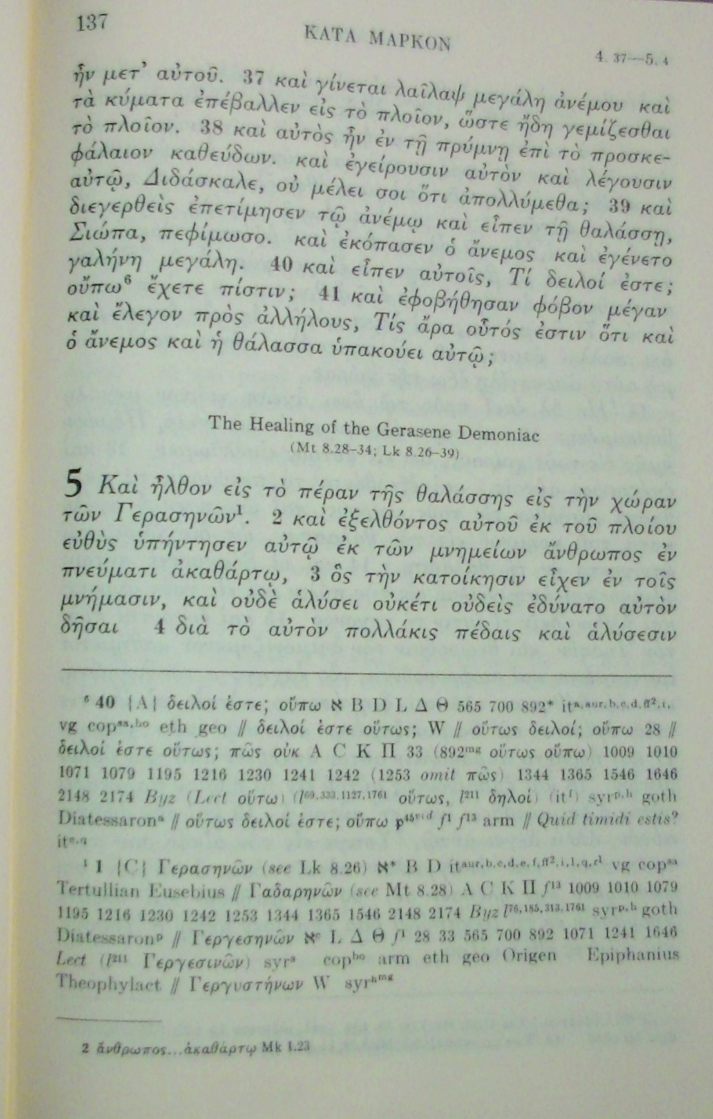

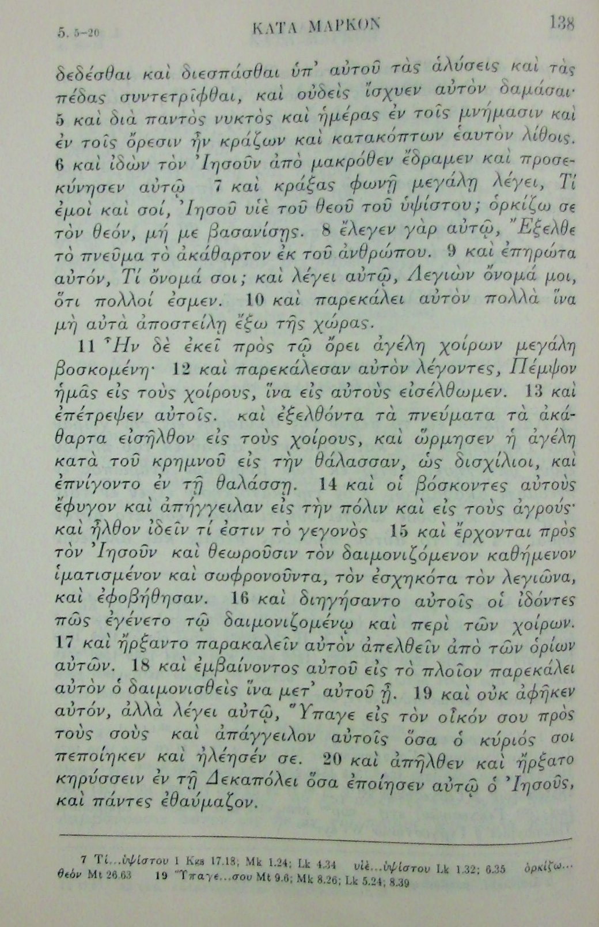

### Aparat critic – UBS4

1 ﻿{C} Γερασηνῶν ﻿(see Lk 8.26) א* B D 2427 itaur, b, c, d, e, f, ff2, i, l, q, r1 vg copsa mssacc. to Origen; Juvencus // Γαδαρηνῶν ﻿(see Mt 8.28) A C ƒ13 157 180 597 1006 1010 1243 1342 1505 Byz [E F G H Σ] l 68 l 76 l 292 l 514 l 673 l 813 l 1223 l 1552 lAD syrp, h Diatessaronsyr mssacc. to Origen // Γεργεσηνῶν ﻿א2 L Δ Θ ƒ1 28 33 205 565 579 700 892 1071 1241 1424 Lect syrs copbo arm eth geo slav Diatessaronarm Origen Hesychius // Γεργυστηνῶν ﻿W syrhmg (Epiphanius Γεργεσθᾶν﻿)

*

2 ἄνθρωπος … ἀκαθάρτῳ Mk 1.23

a 5.5 ﻿SP: NA // P: TEV FC NIV

*

7 Τί … ὑψίστου 1 Kgs 17.18; Mk 1.24; Lk 4.34 υἱὲ … ὑψίστου Lk 1.32; 6.35 ὁρκίζω … θεόν Mt 26.63

b 7 ﻿P: FC VP

c 8 ﻿P: TEV FC NIV VP

d 9 ﻿P: FC VP

e 10 ﻿NO P: TR WH AD M RSV Seg VP Lu NJB TOB REB NRSV // SP: NA

f 12 ﻿P: FC VP

g 13 ﻿P: NA RSV TEV FC NIV VP REB NRSV

h 16 ﻿P: TEV

i 17 ﻿P: NA TEV Seg FC NIV VP

k 18 ﻿P: TEV

*

19 Ὕπαγε … σου Mt 9.6; Mk 8.26; Lk 5.24; 8.39

l  19 ﻿P: TEV FC VP

m 20 ﻿P: WH AD NA M RSV REB NRSV

### Aparat critic STEPBible (Tyndale House, Cambridge) https://www.stepbible.org/?q=version=VarApp|reference=Mar.5

## Mark 5

#### Mark 5.1

ἦλθον]

ἦλθεν]

Γερασηνῶν] (see Luke 8:26)

Γαδαρηνῶν] (see Matthew 8:28) A C E F G H K Π Σ f13 157 180 597 1006 1009 1010 1079 1195 1216 1230 1242 1243 1253 1342 1344 1365 1505 1546 2148 2876 Byz l68 l76 l185 l292 l313 l514 l673 l813 l1223 l1552 l1761 lAD syrp syrh goth Diatessaronsyr mssaccording to Origen ς ND Dio

Γεργεσηνῶν]

See [A Student's Guide to New Testament Textual Variants](http://bible.ovc.edu/tc/lay04mrk.htm#mk5_1),

**TEXT Mark 5.1:** "to the country of the Gerasenes."  
EVIDENCE: S* B D lat vg cop(south)  
TRANSLATIONS: ASV RSV NASV NIV NEB TEV  
RANK: C

**NOTES:** "to the country of the Gergesenes."  
EVIDENCE: Sc L Delta Theta *f*1 28 33 565 700 892 1241 Lect syr(s) syr(h)margin cop(north)  
TRANSLATIONS: RSVn NIVn

**NOTES:** "to the country of the Gadarenes."  
EVIDENCE: A C K Pi *f*13 1010 Byz syr(p,h)  
TRANSLATIONS: KJV RSVn NIVn

**COMMENTS:** Gerasa, Gadara, and Gergesa were all cities of the region called Decapolis, so each reading would refer to the same country. It seems most likely that "Gerasenes" was original here and in Luke 8:26, 37, while "Gadarenes" was original in Matthew 8:28. The reading "Gergesenes" seems to have been proposed by Origen, and added to manuscripts under his influence.

#### Mark 5.2

ἐξελθόντος αὐτοῦ] WH

ἐξελθόντι αὐτῷ] Byz ς

εὐθὺς ὑπήντησεν]

ὑπήντησεν] B it syrs syrp

εὐθέως ἀπήντησεν] A Byz ς

ἀπήντησεν] W

#### Mark 5.3

μνήμασιν] WH

μνημείοις] Byz ς

#### Mark 5.4

οὐδὲ ἁλύσει οὐκέτι] WH NR (CEI Nv) Riv TILC NM

οὔτε ἁλύσεσιν] Byz ς ND Dio

ἐδύνατο] Byz WH

ἠδύνατο] ς

ἴσχυεν αὐτὸν] WH

αὐτὸν ἴσχυεν] Byz ς

#### Mark 5.5

διὰ παντὸς] Byz WH

διαπαντὸς] ς

μνήμασιν καὶ ἐν τοῖς ὄρεσιν] WH NR CEI ND Riv Dio TILC Nv NM

ὄρεσιν καὶ ἐν τοῖς μνήμασιν] Byz ς

#### Mark 5.6

καὶ ἰδὼν] WH

ἰδὼν δὲ] Byz ς

αὐτὸν] A B C L Δ 892 1241 pc WH

αὐτῷ]

#### Mark 5.7

λέγει] WH

εἶπεν] Byz ς

#### Mark 5.9

ὄνομά σοι] WH

σοι ὄνομά] Byz ς

λέγει αὐτῷ] WH NR CEI Riv TILC Nv NM

ἀποκριθῇ λέγων] E 565 700 1010 Byz ς ND Dio

ἀποκριθῇ] D pc it

Λεγιὼν]

Λεγεὼν]

αὐτὸν πολλὰ]

αὐτοὺς πολλὰ] (A πολλὰ αὐτοὺς) D f1 f13 565 700

#### Mark 5.10

αὐτὰ ἀποστείλῃ] B C Δ WH NR CEI

ἀποστείλῃ αὐτὰ] Θ

αὐτοὺς ἀποστείλῃ] D Byz ς ND Riv Dio TILC Nv (NM)

ἀποστείλῃ αὐτοὺς] A 074 f1 f13 1241 al it

αὐτὸν ἀποστείλῃ]

ἀποστείλῃ αὐτὸν] K W 892 al

#### Mark 5.11

τῷ ὄρει] Byz WH

τὰ ὄρη] ς

#### Mark 5.12

λέγοντες]

εἶπαν] W

εἶπον] f13 28 2542

πάντες οἱ δαίμονες λέγοντες] A (K M Π* 579 al it vg syrs syrp omit πάντες) 074 33 Byz syrh goth ς NR CEI ND Riv Dio TILC

πάντα τὰ δαιμόνια εἰπόντα] (D omit πάντα) Θ 565 (700 λέγοντα ὅτι) pc ita

#### Mark 5.13

ἐπέτρεψεν αὐτοῖς]

ἐπέτρεψεν αὐτοῖς εὐθέως ὁ Ἰησοῦς] A 074 f13 33 (1241) Byz itaur itf itl itq vg syrh goth ς ND Dio

ἔπεμψεν αὐτοὺς] Θ

ἔπεμψεν αὐτοὺς ὁ Ἰησοῦς] 565 700

εὐθέως Κύριος Ἰησοῦς ἔπεμψεν αὐτοὺς εἰς τοὺς χοίρους] D pc (itc) itd itff2 itr1 (iti)

ἐπέτρεψεν αὐτοῖς ὁ Ἰησοῦς] 579

ἐπέτρεψεν αὐτοῖς εὐθέως] E

ἔπεμψεν αὐτοὺς εὐθέως ὁ Ἰησοῦς] H U al

ὡς] WH

ἦσαν δὲ ὡς] Byz ς

καὶ οἱ] WH

οἱ δὲ] Byz ς

αὐτοὺς] WH NR Riv Nv NM

τοὺς χοίρους] Byz ς ND Dio TILC

ἀπήγγειλαν]

ἀνήγγειλάν] W Δ f13 28 565 1010 Byz ς

ἦλθον] WH

ἐξῆλθον] Byz ς

#### Mark 5.11

καθήμενον] WH NR CEI ND Riv TILC Nv NM

καθήμενον καὶ] Byz ς Dio

τὸν ἐσχηκότα τὸν λεγιῶνα]

τὸν ἐσχηκότα τὸν λεγεῶνα]

omit] D vg syrs

καὶ διηγή] ς WH

διηγή δὲ] Byz

#### Mark 5.17

ἤρξαντο παρακαλεῖν] Byz ς WH

παρεκάλουν] D Θ 565 700 1424 pc ita

ἐμβαίνοντος] WH NR CEI ND Riv Nv NM

ἐμβάντος] Byz ς Dio (TILC)

παρεκάλει] Byz ς WH

μετ' αὐτοῦ ᾖ] WH

ᾖ μετ' αὐτοῦ] Byz ς

καὶ οὐκ] WH CEI Nv NM

ὁ δὲ Ἰησοῦς οὐκ] Byz ς NR ND Riv Dio TILC

ἀπάγγειλον]

διάγγειλον] p45 D W f1 f13 28 700 pc

ἀνάγγειλον] A L 0132 0134 Byz ς

#### Mark 5.19

ὁ κύριός σοι] (

σοι ὁ κύριός] A L W 074 0132 0134 f1 f13 Byz vg ς

σοι ὁ θεὸς] (*see parallel passage)* D (1242)